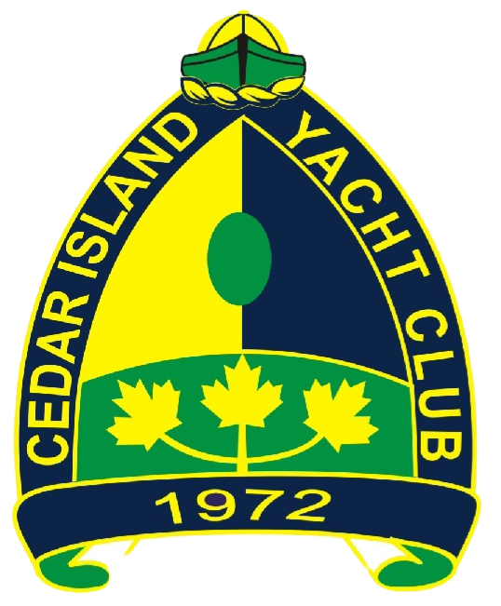

2024 CIYC Maple Leaf Regatta

Notice of Race

1 Rules
1.1 The event is governed by the rules as defined in The Racing Rules of Sailing.
1.2 RRS Appendix RV, Reduced Visibility replaces RRS Part 2 from sunset until sunrise.
1.3 The prescriptions of Sail Canada shall apply.
1.4 If there is a conflict between languages the English text takes precedence.

2 Sailing Instructions
2.1 The sailing instructions will be available on or before July 1st 2024 and will be posted online and on the official notice board.

3 Communication
3.1 The official notice board is located at Cedar Island Yacht Club between the main building and washrooms. Notices will also be posted to the CIYC website.
3.2 All boats shall carry a VHF radio capable of communicating on channels 16, 68, and 72.
3.3 On the water, the race committee will make courtesy broadcasts to competitors on VHF Radio, on channel 72.
3.4 From the first warning signal until the end of the last race of the day, except in an emergency, a boat shall not make voice or data transmissions and shall not receive voice or data communication that is not available to all boats.

4 Eligibility and Entry
4.1 The event is open to all boats, with submission of an entry on Notice of Race (http://www.noticeofrace.net/) or entry notice sent by email to Kevin Alles at kevin.sailor@gmail.com. The entry fee of $35 CAD must be sent as an e-transfer treasurerciyc@gmail.com by July 4th at 8pm.
4.2 All boats should have a valid PHRF certificate from a recognized rating authority. Boats which do not have a valid certificate will be assigned a rating based on PHRF-LE, EC-PHRF, PHRF-LO, Midwest PHRF, or other rating sources at the determination of the Scorer or CIYC Race Committee.
4.3 The PHRF handicapping system applies to all boats.
4.4 The classes are defined as follows:
Class | Ratings | Class Flag
PHRF Spinnaker | All PHRF ratings | Code Flag 1
PHRF JOG A | NFS PHRF Rating <= 200 | Code Flag 2
PHRF JOG B | NFS PHRF Rating >200 | Code Flag 3

4.5 All boats shall be scored as JOG unless they notify the Scorer or CIYC Race Committee prior to the first race in a series. Boats may change class at the start of each series or event by informing the race director prior to the first race in a series or event. Boats which change classes will be disqualified from overall awards.
4.6 A list of all eligible boats and their class shall be published with the sailing instructions.

5 Schedule
5.1 The regatta shall consist of one race, starting at 10:00 AM on July 6th, 2024
5.2 No warning signal shall be made more than 45 minutes after the time of the first signal.

6 Venue & Courses
6.1 NoR Addendum 1 shows the location of the racing areas.
6.2 NoR Addendum 2 lists the courses and their lengths.

7 Scoring
7.1 The regatta shall be scored as provided in Appendix A of the RRS, with PHRF corrected times using time-on-time.

8 Risk Statement
8.1 RRS 3 states: ‘The responsibility for a boat’s decision to participate in a race or to continue to race is hers alone.’ By participating in this event each competitor agrees and acknowledges that sailing is a potentially dangerous activity with inherent risks. These risks include strong winds and rough seas, sudden changes in weather, failure of equipment, boat handling errors, poor seamanship by other boats, loss of balance on an unstable platform and fatigue resulting in increased risk of injury. Inherent in the sport of sailing is the risk of permanent, catastrophic injury or death by drowning, trauma, hypothermia or other causes.

9 Insurance
9.1 Each participating boat shall be insured with valid third-party liability insurance with a minimum coverage of $2 million CAD per incident or the equivalent.
9.2 CIYC’s insurance will cover any boat acting as a committee boat while they are performing those duties.

10 Prizes
10.1 Prizes shall be awarded to first, second, and third places in each class. The CIYC Race Committee may award other prizes in addition to those listed.

11 Further Information
11.1 For further information please contact the Kevin Alles at kevin.sailor@gmail.com

Addendum 1: Racing Area
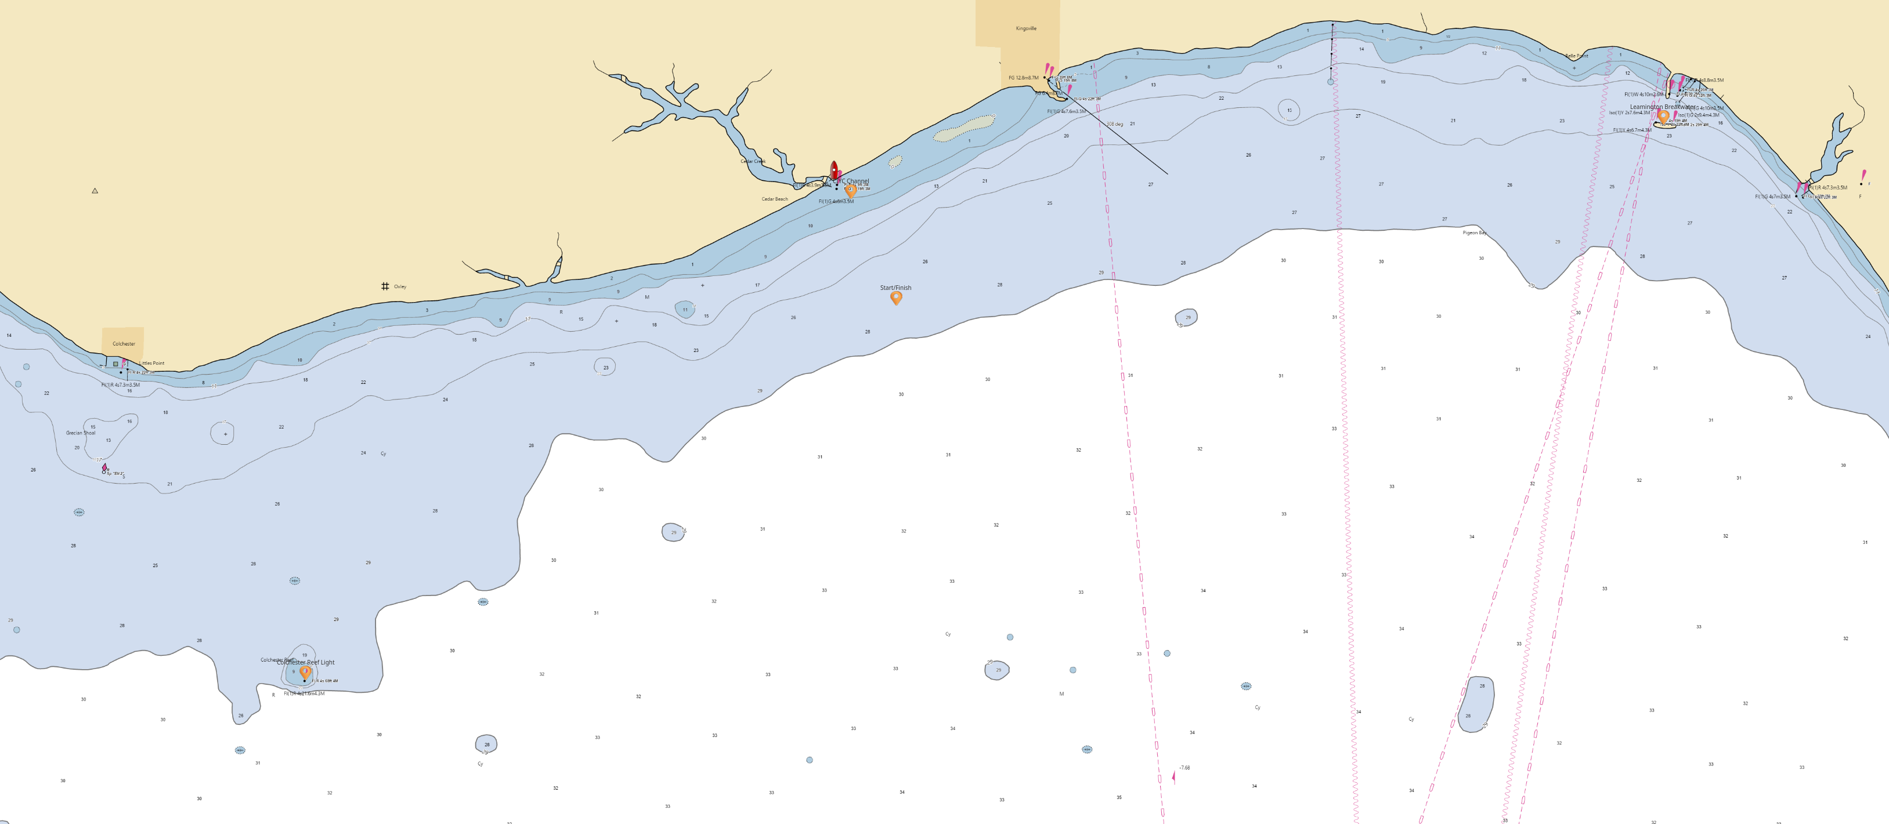

Mark | Description | Latitude | Longitude
Start/Finish Mark | White Mark | 41.99145° N | 82.76669° W
Colchester Reef Light | Lighthouse | 41.93239° N | 82.89174° W
Leamington Breakwater | Stone Breakwater | 42.01996° N | 82.60425° W
CIYC Channel |  | 42.00822° N | 082.77624° W

Addendum 2: Courses
Course | Marks
1 | Start Line, round Colchester Reef Light to port, Finish Line
2 | Start Line, round the Leamington Breakwater to port, Finish Line

See: Appendix RV, Reduced Visibility
See: Sail Canada Prescriptions 2021
“Jib or Genoa”
As identified by the CIYC race committee

